__________________________________________________________________

**Central Florida Regional Planning Model**

**Version X.X**

**Model Description Report**

__________________________________________________________________

**NAME**



**Prepared for the**

**Florida Department of Transportation**

**Updated By**

**Firm**

**Address**

**DATE**

Table of Contents

1 Introduction 1

1.1 Regional Travel Patterns 3

1.1.1 Commute Mode Share 3

1.1.2 Commuter Direction / Balance 4

1.2 Version x.x Updates 5

1.2.1 Usage of the CFRPM Vx.x Model 5

2 Traffic Analysis Zones and socio-economic Data 6

2.1 TAZ Development 6

2.2 Household Data 6

2.2.1 Data Sources 6

2.2.2 Data Description and Validation 7

2.3 Employment Data 8

2.3.1 Data Sources 8

2.3.2 Data Description and Validation 8

2.4 Special Generator Data 9

2.4.1 Data Sources 9

2.4.2 Data Description and Validation 9

2.5 Classification Sub-models 9

2.5.1 Vehicle Ownership 9

2.5.2 Household Classification 10

2.5.3 Area Type Definitions 10

2.6 CFRPM District Geography 10

2.6.1 Need for District Geography 10

2.6.2 Criteria for Establishing Districts 10

2.6.3 CFRPM District Geography 10

3 Network Development 11

3.1 Highway Networks 11

3.1.1 Speed 12

3.1.2 Capacity Calculation 12

3.1.3 Development and Checking of Highway Paths 13

3.2 Traffic Counts 13

3.3 Transit Networks 15

3.3.1 Transit Route Coding 16

3.3.2 Transit Speeds 16

3.3.3 Development and Checking of Transit Paths 16

3.3.4 Access Links 17

4 Household Travel Survey and Trip Generation 18

4.1 Household Survey Analysis 18

4.1.1 Data Review, Preparation and Processing 18

4.1.2 Data Adjustments or Re-expansion 18

4.2 Trip Production Model 18

4.2.1 Trip Purpose Determination/Market Stratification 18

4.2.2 Trip Rate Determination 18

4.2.3 Special Market Models 18

4.3 Trip Attraction Model 18

4.3.1 Trip Attraction Rate Determination 18

4.3.2 Special Markets 18

4.4 Trip Adjustments and Balancing 18

5 Trip Distribution 18

5.1 Datasets and Analysis 18

5.2 Model Assertion & Stratification 18

5.3 Model Utility 18

5.3.1 Terminal Times/Intrazonal Travel Time Calculations 19

5.3.2 Friction Factor Definition 19

5.4 Model Calibration and Adjustments 19

6 Truck/Commercial Vehicles 20

6.1 Truck Datasets 20

6.2 Trip Generation 20

6.3 Trip distribution 20

6.4 Calibration 20

7 External Models 21

7.1 EE Trip Model 21

7.1.1 External Trip Data 21

7.1.2 Station Locations 21

7.1.3 External EE Trip Model Estimation 21

7.2 E-I Model 21

7.2.1 EI Trip Generation 21

7.2.2 EI Trip Distribution 21

7.2.3 Time of Day 21

7.2.4 EI Calibration Results 21

8 Time of day 22

8.1 Diurnal Factors by Trip Purpose 22

8.2 Peak Period Determination 22

8.3 Time of Day and Directional Split Factors 22

8.3.1 Factors for Resident Trips 22

8.3.2 Factors for Commercial Vehicles 22

8.3.3 Factors for External Trips 22

9 Transit Data and Analysis 23

9.1 On-Board Survey 23

9.1.1 Survey Analysis 23

9.1.2 Sample & Survey Expansion 23

9.1.3 District Summaries 23

9.1.4 Calibration Targets 23

9.2 Transit Data 23

9.2.1 Transit Modes 23

9.3 Transit Paths 23

9.3.1 Path-Cost Components 23

9.3.2 Transit Skims 23

10 Mode Choice Model Structure 24

10.1.1 Mode-Choice Description 24

10.1.2 Asserted Model Coefficients 24

10.2 Mode-Choice Model Calibration & Results 24

10.2.1 Primary Calibration of Mode Choice Constants 24

10.2.2 Calibration of CBD Attraction Transit Trips/Additional Adjustments 24

10.2.3 Calibration Results & Comparisons 24

11 Highway Assignment 26

11.1 Assignment Methodology 26

11.1.1 Autos 26

11.1.2 Trucks/Commercial Vehicles 26

11.1.3 External-internal 26

11.2 Volume Delay Curve Development 26

11.3 Traffic Assignment Capacity Factors 26

11.4 Model Adjustments 26

11.5 Reporting Protocol 26

List of Tables

Table 1‑1: Five Year Commute Mode Share (Sample) 4

Table 2‑1: CFRPM Traffic Analysis Zone Summary 6

Table 2‑2: CFRPM Household Data Elements 7

Table 2‑3: CFRPM Special Generators 9

Table 2‑4: CFRPM Summary Districts 10

Table 3‑1: Example User Input Highway Attribute Data 11

Table 3‑2: Example Speed Capacity Lookup Table 12

Table 3‑3: AWDT Traffic Count Locations 14

Table 3‑4: CFRPM Version 6.01 Transit Modes and Operators 15

Table 3‑5: CFRPM Transit Service by Provider with Headways 16

Table 3‑6: Fare Structure for Transit Travel by Provider 16

Table 3‑7: Transit Access Link Coding Values 17

Table 10‑1: Mode Choice Coefficients 25

Table 11‑1: Hourly to Time of Day Factors 26

Table 11‑2: Systemwide Daily Model VMT and VHT by County with Total 26

Table 11‑3: Systemwide TOD Model VMT and VHT by County with Total 26

Table 11‑4 Systemwide Daily Model VMT and VHT by Functional Class 26

Table 11‑5: Systemwide TOD Model VMT and VHT by Functional Class 26

Table 11‑6: Screenline/Cutline Traffic Summary 26

List of Figures

Figure 1‑1: CFRPM Model Flow Diagram 2

Figure 1‑2: Example Model Extent 3

Figure 1‑3: Orange County Worker Flows 4

Figure 2‑1: CFRPM Traffic Analysis Zone System 6

Figure 2‑2: CFRPM Summary Districts 10

Figure 3‑1: Example Highway Path Check 13

Figure 3‑2: AWDT Traffic Count and Screenline Locations 14

Figure 3‑3: CFRPM Regional Transit Coverage 15

Figure 3‑4: Example of Transit Access Link Coding 17

Figure 10‑1: CFRPM Mode Choice Structure 24

List of Appendices

Appendix A – TAZ Level Socioeconomic Data

List of Acronyms

AADT Average Annual Daily Traffic

ACS American Community Survey

BCA Benefit Cost Analysis

BPR Bureau of Public Roads

CFRPM Central Florida Regional Planning Model

DOT Department of Transportation

ELToD Express Lanes Time of Day

ESC Employment Security Commission

FAF Freight Analysis Framework

**FDOT** Florida Department of Transportation

FHWA Federal Highway Administration

FIPS Federal Information Processing Standard

FSUTMS Florida Standard Urban Transportation Model Structure

GIS Geographic Information System

GUI Graphic User Interface

HBO Home-Based Other Trips

HBW Home-Based Work Trips

HBS Home-Based Shop Trips

LOS Level of Service

LRTP Long Range Transportation Plan

MPO Metropolitan Planning Organization

MUT Multi-Unit Trucks

NAICS North American Industry Classification System

NHB Non-Home-Based Trips

NHO Non-Home Other Trips

NHW Non-Home Work Trips

NHTS National Household Travel Survey

RMSE Root Mean Squared Error

SAS Statistical Analysis System

SUT Single-Unit Trucks

TAZ Traffic Analysis Zone

TOD Time-of-Day

TRB Transportation Research Board

V/C Volume-to-Capacity Ratio

VHT Vehicle Hours Traveled

VMT Vehicle Miles Traveled

# Introduction

The Central Florida Regional Planning Model (CFRPM) has undergone a systematic set of updates and changes in the period 2012-2014. In this methodology report, the most recent and substantive changes will be cited in order to provide background to the model users in years to come. In 2014, the Florida Department of Transportation (FDOT) funded a comprehensive update culminating in the report entitled “Technical Memorandum: Year 2010 Model Calibration and Validation", which presented the model related tasks that were performed. These tasks were both software and model related and included an expansion of dummy zones available to the model, an improvement of external-to-external assigned paths, an update of the node attribute "MPO", assessment and modification of trip rates, an update to Cube Version 6.4 (e.g. 6.4.1), the incorporation of the Express Lanes Time of Day (ELToD) Model, the creation of customized MPO and BCA reports, the creation of a streamlined subarea analysis using fixed districts, the development of a sketch-planning module, and the development of a GUI styled menu. The 2012 CFRPM model has become the base upon which the next round of updates will be built.

The CFRPM is a traditional four step model that includes trip generation, trip distribution, mode choice and traffic assignment. Additional components that are included in the model include a household disaggregation model which develops household distributions required by the trip generation as well as separate truck and external models. The model includes a Time of Day structure that includes four periods: AM peak (6am to 9am), midday (9am to 2pm), PM peak (2pm to 6pm) and overnight. Figure 1‑1 shows the model flow including each model module and its relationship to the other.

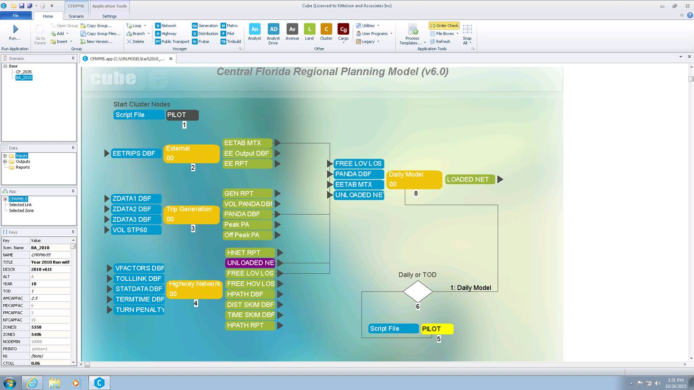

Figure ‑: CFRPM Model Flow Diagram

This CFRPM description report will be organized following the four step model sequence shown above and include, in the general order that the model operates:

* Socio-Economic Data
* Networks
* Trip Generation, including the vehicle ownership model
* Trip Distribution
* Mode Choice
* Traffic Assignment
* Truck Model
* Feedback Loop

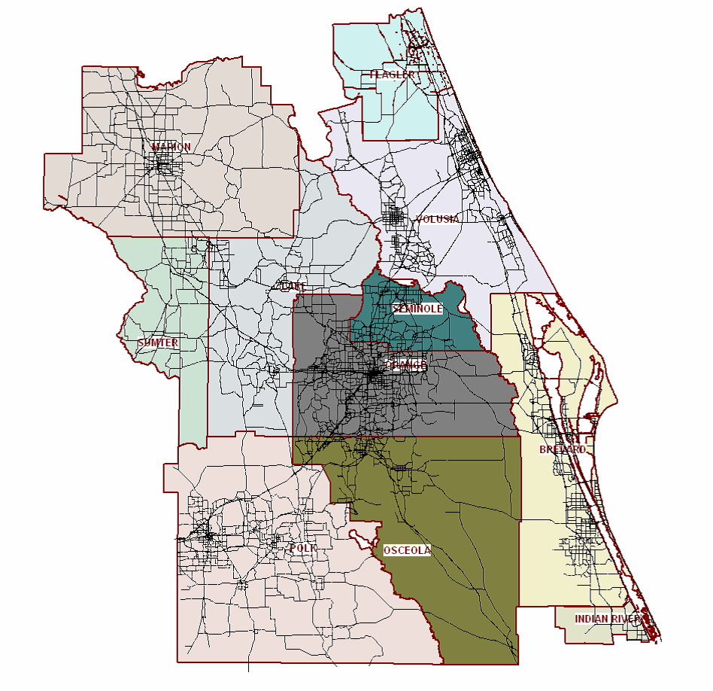The base year of the travel model is currently 2010; this base and the horizon years of the CFRPM will be updated with the upcoming model validation and calibration, consistent with the requirements of the MPO. Additional detail of each model component as well as newly added features such as a visitor model will be added as they enter the CFRPM. **Error! Reference source not found.** presents a map of the model boundaries.

Figure 1‑2: Example Model Extent

## Regional Travel Patterns

Travel patterns in the CFRPM region are complex, i.e. inter county, and generally auto-oriented. In this section two data reviews will be provided to capture the travel patterns of the region:

American Community Survey (ACS) mode share 2009-2015.

Inter and intra-county workers flows using U.S. Census Bureau Longitudinal Employer-Household Dynamics (LODES) data.

It is expected that the CFRPM will continue to be designed to capture the complexity of the travel patterns that emerge from this data review. The dependence on auto travel for work trips, either as a driver or passenger, is an important part of understanding the region’s travel patterns.

### Commute Mode Share

Table 1‑1 shows that in Orange County, driving alone is the dominant mode of travel to work, registering around 80% of total work trips between 2009 and 2013, according to ACS estimates. Carpooling accounts for about 12% of commute trips, while telecommuting, non-motorized modes, and public transit account for the remaining 8%. These commute mode shares have remained stable over the latest 5 years of ACS 5-year estimates.

Table ‑: Five Year Commute Mode Share (Sample)

|  |  |  |  |  |  |
| --- | --- | --- | --- | --- | --- |
| Mode | 2009 | 2010 | 2011 | 2012 | 2013 |
| Drove Alone | 79.3% | 80.2% | 80.1% | 79.3% | 79.4% |
| Carpooled | 12.7% | 11.8% | 11.8% | 12.2% | 12.3% |
| Public Transit | 0.5% | 0.6% | 0.6% | 0.7% | 0.9% |
| Walked or Bicycled | 2.3% | 2.4% | 2.7% | 3.1% | 3.0% |
| Other | 1.3% | 1.1% | 1.1% | 1.1% | 1.1% |
| Worked at Home | 3.8% | 3.8% | 3.7% | 3.6% | 3.4% |

*Source: American Community Survey, accessed 2015*

### Commuter Direction / Balance

The U.S. Department of Commerce with the U.S. Census Bureau maintains a number of data programs related to employment statistics. The online data and informational site known as Longitudinal Employer-Household Dynamics (LODES) makes available several data products that may be used to research and characterize workforce dynamics for specific groups such as a county or a Census Place. The LODES website also provides a geographic crosswalk allowing the county-to-county as well as place-to-place information in Orange County to be summarized. Figure 1‑3 shows the county level picture with respect to commuting.

As shown by the circular green arrow, 376,445 workers both live and work within the county. The two straight green arrows show all work trips coming into Orange County (404,692) from any direction or leaving the county to work in any direction (179,791). Note that while the arrows are placed at the west and east borders of the county, the work trips are flowing to and from all points outside the county.

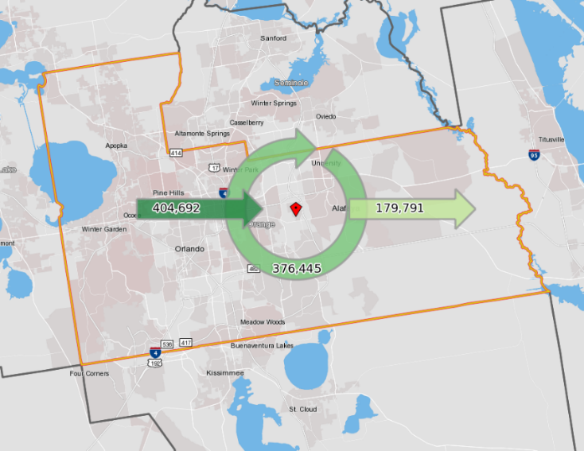

Figure 1‑3 communicates that Orange County residents generally live and work within the county but that the county attracts workers from outside the county and sends some residents to work locations outside Orange County.



Figure 1‑3: Orange County Worker Flows

The significance of reviewing workers flows is that, in general, work trips generate about 1 in 5 of all person trips made in a region and thus account for a significant portion of daily traffic congestion. Work trips are typically made in the peak periods requiring attention to the peak hour performance of major highway facilities. Understanding the mode and flow of trips in the CFRPM region builds understanding of what traffic patterns are and frames the requirements of the travel model.

## Version x.x Updates

This section would define what has changed in this version of the model. This section should provide a few paragraphs of detailed summary to allow the reader to understand the overall changes.

Include development dates of this version

A numbered bulleted list of the changes should be included in this section and linked to the proper location in the documentation.

1. Time of Day Periods added
2. New Assignment Methodology
3. Etc.

### Usage of the CFRPM Vx.x Model

* Define how the newly changed components should or should not be used.
* Include example(s) of the intended analysis abilities by providing real world tests if possible

# Traffic Analysis Zones and socio-economic Data

## TAZ Development

* Discussion of the number of TAZs and how they were chosen and explanation of the numbering system.
  + Include chart to show reserved dummy nodes if applicable
* Map of the TAZs and external station locations should be provided
* Include a summary of TAZs by type as well as by county or region. An example is shown below:

Table 2‑1: CFRPM Traffic Analysis Zone Summary

|  |  |  |
| --- | --- | --- |
| **Zone Type** | **TAZ Count** | **TAZ Range** |
| Internal | 174 | 1-499 |
| External | 25 | 501-530 |
| Total | 199 | ------ |

Figure 2‑1: CFRPM Traffic Analysis Zone System

<Insert here>

## Household Data

### Data Sources

* Descriptions of the sources of the datasets used for the development of HH data
  + Include links/references to original dataset where applicable

### Data Description and Validation

* Description of the revisions/cleaning of these datasets including documentation of adjustments made to input data and why they were necessary.
  + If adjustments are made to data they should be documented using the following outline:
    - Purpose of the Adjustment
    - Methodology Used
    - Results of Adjustment
      * Example figures of issues determined and how resolved if applicable
* Reference to additional validation datasets were applicable
* Table to show data elements as shown in Table 2‑2.

Table ‑: CFRPM Household Data Elements

|  |  |  |  |
| --- | --- | --- | --- |
| Data Element | Description | Where Obtained | Manual Adjustments Required |
| TAZ | TAZ Numbers |  |  |
| SFDU | Single Family Dwelling Units | Census data | no |
| SF_PCTVNP | Percentage of Single Family are Vacation and Non-Permanent Resident Homes |  |  |
| SF_PCTVAC | Percentage of Single Family are Vacation Homes |  |  |
| SFPOP | Single Family Population |  |  |
| SF_0AUTO | Single Family Percentage of 0 Auto |  |  |
| SF_1AUTO | Single Family Percentage of 1 Auto |  |  |
| SF_2AUTO | Single Family Percentage of 2+ Auto |  |  |
| MFDU | Multiple Family Dwelling Units |  |  |
| MF_PCTVNP | Percentage of Multiple Family are Vacation and Non-Permanent Resident Homes |  |  |
| MF_PCTVAC | Percentage of Multiple Family are Vacation Homes |  |  |
| MFPOP | Multiple Family Population |  |  |
| MF_0AUTO | Multiple Family Percentage of 0 Auto |  |  |
| MF_1AUTO | Multiple Family Percentage of 1 Auto |  |  |
| MF_2AUTO | Multiple Family Percentage of 2+ Auto |  |  |
| HMDU | Hotel Motel Dwelling Units |  |  |
| HMOCC | Hotel Motel Occupancy Percentage |  |  |
| HMPOP | Hotel Motel Population |  |  |

Or text Example:

Household and population data was obtained from the *2010 Census* *Group SF1*. Data from the block level was summarized to the TAZ level. The following SE data fields were obtained from this source:

* Households – total number of households within the TAZ
* Population – total number of people living within the TAZ

Population = GQ_Population + HH_Population

* GQ_Population – total number of people living in Group Quarters within the TAZ
* HH_Population – total number of people living in households within the TAZ
* Include in Appendix the final numbers used for every TAZ as a reference

## Employment Data

* General Description of the datasets used and how they are used in the model

Example: 2010 employment data was obtained from InfoGroup and then verified by random sample checking the number of employees by phone or based on local knowledge. Upon the completion of this process, staff members created a geocoded employment database that included each employer by name, physical address, number of employees and employment type. Employment type was grouped into five main categories.

### Data Sources

* Descriptions of the sources of the datasets used for the development of employment data
  + Include links/references to original dataset where applicable

### Data Description and Validation

Detailed definitions for employment groupings including the NAICS codes. Example shown below.

* Industrial (SIC Groups 1-49) – Includes employment such as manufacturing, agriculture, construction, and freight services.
* Retail (SIC Groups 50-54, 56, 57, 59) – Includes wholesale trade and retail trade.
* Highway Retail (SIC Groups 55 and 58) – Includes retail that falls into the category of fast food restaurants, service stations, banks, post office and other types of eating and drinking establishments.
* Office (SIC Groups 60-67, 91-97) – Includes finance, insurance, real estate, and governmental type offices.
* Service (SIC Groups 70-76, 78-89, 99) – Employment data falling into this category are generally classified as personal and business services, auto repair, and other service type establishments.

• Description of the revisions/cleaning of these datasets including documentation of adjustments made to input data and why they were necessary.

* + If adjustments are made to data they should be documented using the following outline:
    - Purpose of the Adjustment
    - Methodology Used
    - Results of Adjustment
      * Example figures of issues determined and how resolved if applicable
* Reference to additional validation datasets were applicable
* Table to show data elements

## Special Generator Data

What decisions led to the use of special generators in the model

### Data Sources

* Descriptions of the sources of the datasets used for the development of special generators

### Data Description and Validation

* How were these data assumptions used and validated in the model?
* Table of special generators by zone including the attributes shown in Table 2‑3:

Table ‑: CFRPM Special Generators

|  |  |  |  |
| --- | --- | --- | --- |
| **Model TAZs** | **Name of Generator** | **County** | **Type of Generator** |
| 118, 171 | AB Tech-Main Campus | Osceola | College |

## Classification Sub-models

### Vehicle Ownership

* How was the submodel developed?
  + What estimation was done
* What data sets were used and why?
* What validation of the submodel was performed?
* Plots of the resulting curves or outputs from the submodel
  + Plot of ACS vs Model estimation
* Include final coefficients in a table

### Household Classification

* How was the submodel developed?
* What data sets were used and why?
* What validation of the submodel was performed?
* Plots of the resulting curves or outputs from the submodel
  + Include raw and smoothed results
* Validation of submodels depends on stratification but should include:
  + Household Size Submodel Estimated to Observed by County
  + Income Submodel Estimated to Observed by County
  + Workers per Household Submodel Estimated to Observed by County
  + Table of Estimated vs. Observed by District

### Area Type Definitions

* How is area type defined and what values are needed for these calculations
  + How are the area types smoothed
* Plots of resulting area type for verification

## CFRPM District Geography

### Need for District Geography

### Criteria for Establishing Districts

### CFRPM District Geography

* Provide table of the districts with IDs and Names.
* Provide map of the districts with the TAZs shown.

Table ‑: CFRPM Summary Districts

Figure ‑: CFRPM Summary Districts

District geography sets the scene for summaries of both socioeconomic and travel demand results.

# Network Development

The highway network contains the information relating to the roadways simulated by the model. Each roadway is represented by a set of nodes and links, which represent its physical location. The model network serves as the basis for the highway assigned trips. Highway networks consist of:

* Nodes - elements that describe the position of intersections or shape points on roadway networks.
* Links - network model elements that connect the nodes and have attributes including direction, speed, capacity, and highway functional classification.
* Centroid Connectors connect the zones to the network. They represent the distance and time to be covered between a zone’s center of gravity (the center of trip generating and attracting activity) and the model links serving that zone.

## Highway Networks

* What data was used for the network development?
* Plots of countywide/regional coded speeds and # of lanes to show validation
* Discussion on the Validation that network paths have been checked
  + Interactive path traces
  + Checking zero volume links
* A description of the fields coded in the network should be provided. This table should be designate which fields are user input versus calculated by the model; see Table 3‑1.

Table ‑: Example User Input Highway Attribute Data

|  |  |  |
| --- | --- | --- |
| **Field Name** | **Description** | **User Input or Calculated** |
| Street Name | Common street name | Input |
| Route Number | Common route name | Input |
| AREA_Type | Calculated values of area type | Calculated |
| COUNTY | County name | Input |
| FUN_CLASS | Functional Classification:  0 = not classified  1 = Interstate  2 = Principal Arterial Other Freeway  3 = Principal Arterial Other  4 = Minor Arterial  5 = Major Collector  6 = Minor Collector  7 = Local |  |

### Speed

* How are free flow and default congested travel speeds calculated in the model?
* Table of speed assumptions by facility type should be included; an example is Table 3‑2.
* Any data used for validation of these speeds?

### Capacity Calculation

* How is capacity calculated?
  + Include formulas/reference and capacity table where appropriate
* What values are needed and how does the model get to peak period capacities?

|  |  |  |
| --- | --- | --- |
| **Functional Class** | **Posted Speed** | **Capacity** |
| Interstate | 85 | 2400 |
| 80 | 2400 |
| 75 | 2400 |
| 70 | 2400 |
| 65 | 2350 |
| 60 | 2300 |
| 55 | 2250 |
| Expressway | 65 | 2000 |
| 60 | 2000 |
| 55 | 1850 |
| 50 | 1700 |
| 45 | 1550 |
| 40 | 1500 |
| 35 | 1450 |
| 30 | 1400 |
| 25 | 1350 |
| Principal Arterial | 65 | 1800 |
| 60 | 1800 |
| 55 | 1800 |
| 50 | 1200 |
| 45 | 1000 |
| 40 | 900 |
| 35 | 850 |
| 30 | 800 |
| 25 | 800 |
| Minor Arterial | 55 | 1000 |
| 50 | 1000 |
| 45 | 850 |
| 40 | 850 |
| 35 | 750 |
| 30 | 700 |
| 25 | 700 |
| 20 | 650 |
| 15 | 650 |
| Collector | 55 | 850 |
| 50 | 850 |
| 45 | 650 |
| 40 | 650 |
| 35 | 650 |
| 30 | 650 |
| 25 | 650 |
| 20 | 650 |
| 15 | 600 |
| 10 | 600 |

Table 3‑2: Example Speed Capacity Lookup Table

### Development and Checking of Highway Paths

A small set of representative highway paths will be checked as part of network fidelity review. Both distance and time, including peak time periods representing congestion, will be tested. Figure 3‑1 provides an example.

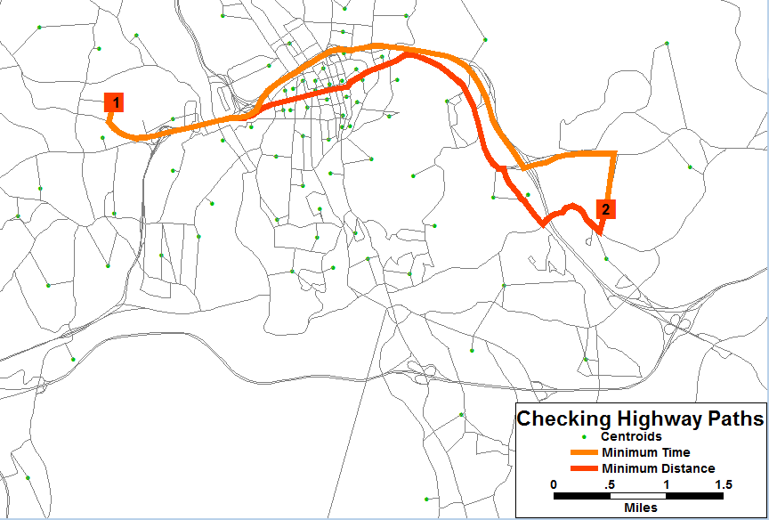

Figure 3‑1: Example Highway Path Check

## Traffic Counts

* Discussion of the count information used in the model. Including year of counts, count types and how the counts were prepared as a part of the model development
  + Table of counts including unique count ID, highway network link ID, count type, count source, road on, location description, and average weekday count (AWDT) as shown in Table 3‑3.

Table 3‑3: AWDT Traffic Count Locations

* Map of count location and screenline locations and numbering

Typically, screenlines follow natural boundaries and barriers, such as rivers, streams, railroad tracks, and access controlled facilities, as deemed appropriate in each region. Cutlines are applied with different goals, and have been used to capture movements in particular corridors. Legacy screenlines and cutlines will be used in establishing the next generation of these key validation tools. The screenlines and cutlines will also be tied to the location of permanent traffic counts, important transportation projects (past and planned) and key corridors.

Figure ‑: AWDT Traffic Count and Screenline Locations

## Transit Networks

In this section, the CFRPM transit network approach will be presented as follows:

* Transit system overview on the ground
* Transit network components, coding and quality checks.

The CFRPM region contains multiple transit providers and services consistent with the multiple MPOs. The transit coverage is shown in Figure 3‑3. Each transit operator has a unique system name and corresponding mode operator number as shown in Table 3‑4.

Figure ‑: CFRPM Regional Transit Coverage

Table 3‑4: CFRPM Version 6.01 Transit Modes and Operators



### Transit Route Coding

* What year & month are the routes from?
* What are the modes coded?
* How many routes are coded?
* List of routes including route name, route ID and their peak and offpeak headways so they can be referenced
  + Pdfs of the online route info for reference
* What fare is used?
  + How was the fare calculated

Table 3‑5: CFRPM Transit Service by Provider with Headways

Table 3‑6: Fare Structure for Transit Travel by Provider

### Transit Speeds

* What speed functions are being used?
* How were they developed/adjusted/calibrated?

### Development and Checking of Transit Paths

* A description of how the paths were verified in the model
* What path builder setting and weights are being assumed

### Access Links

* Details on how are access links coded in the model?
* Included should be a table of the access link coding values and a picture of what they represent

Table ‑: Transit Access Link Coding Values

Figure ‑: Example of Transit Access Link Coding

# Household Travel Survey and Trip Generation

## Household Survey Analysis

### Data Review, Preparation and Processing

#### Household Data Summary

#### Person Data Summary

#### Trip Data Summary

### Data Adjustments or Re-expansion

## Trip Production Model

### Trip Purpose Determination/Market Stratification

### Trip Rate Determination

#### Initial/Raw vs Smoothed/Adjusted

### Special Market Models

## Trip Attraction Model[1]

### Trip Attraction Rate Determination

#### Estimation/Analysis

#### Initial/Raw vs Smoothed/Adjusted

### Special Markets

## Trip Adjustments and Balancing

# Trip Distribution

## Datasets and Analysis

## Model Assertion & Stratification

* Estimated or Borrowed Coefficients

## Model Utility

* Gravity Model or Destination Choice

### Terminal Times/Intrazonal Travel Time Calculations

### Friction Factor Definition

* Function or Lookup table
* District Definitions

## Model Calibration and Adjustments

* TLFD Curves-Estimated vs Observed
* District Summaries

# Truck/Commercial Vehicles

## Truck Datasets

## Trip Generation

## Trip distribution

## Calibration

# External Models

## EE Trip Model

### External Trip Data

### Station Locations

### External EE Trip Model Estimation

## E-I Model

### EI Trip Generation

### EI Trip Distribution

### Time of Day

### EI Calibration Results

# Time of day

The CFRPM has established and maintained four time periods since the time of the 2010 Model Calibration and Validation. In 2010, the derivation of the four time periods was based on a thorough review of local traffic counts and the trip purposes from the 2008 National Household Travel Survey (NHTS) and their daily distribution patterns, along with LYNX transit service. Data from travel speed corridor studies, including those associated with I-4, were also used. The AM and PM Peak Periods are referred to as the Peak Period and the MD and NT Periods are referred to as the Off-Peak Period.

## Diurnal Factors by Trip Purpose

## Peak Period Determination

## Time of Day and Directional Split Factors

### Factors for Resident Trips

### Factors for Commercial Vehicles

### Factors for External Trips

# Transit Data and Analysis

## On-Board Survey

### Survey Analysis

#### Purposes/Demographics

### Sample & Survey Expansion

### District Summaries

### Calibration Targets

## Transit Data

### Transit Modes

#### Transit Access/Egress Connectors

#### Transit Fare

#### Transit Travel Times

## Transit Paths

### Path-Cost Components

### Transit Skims

# Mode Choice Model Structure

This section discusses the CFRPM mode choice. Figure 10‑1provides an overview of the mode choice model structure with respect to the types of model of travel that are distinguished within the CFRPM.

### Mode-Choice Description

### Asserted Model Coefficients

The mode choice coefficients are presented in Table 10‑1.

## Mode-Choice Model Calibration & Results

### Primary Calibration of Mode Choice Constants

### Calibration of CBD Attraction Transit Trips/Additional Adjustments

### Calibration Results & Comparisons



Figure 10‑1: CFRPM Mode Choice Structure

Table 10‑1: Mode Choice Coefficients



# Highway Assignment

## Assignment Methodology

### Autos

### Trucks/Commercial Vehicles

### External-internal

## Volume Delay Curve Development

## Traffic Assignment Capacity Factors

Table 11‑1: Hourly to Time of Day Factors

## Model Adjustments

## Reporting Protocol

The CFRPM highway assignment protocol will include summaries for both VMT and VHT by county and by time of day and daily. Screenline/cutline reports will also be produced after the model run is complete.

Table 11‑2: Systemwide Daily Model VMT and VHT by County with Total

Table 11‑3: Systemwide TOD Model VMT and VHT by County with Total

Table 11‑4 Systemwide Daily Model VMT and VHT by Functional Class

Table 11‑5: Systemwide TOD Model VMT and VHT by Functional Class

Table 11‑6: Screenline/Cutline Traffic Summary

Appendix A – TAZ Level Socioeconomic Data

1. Depends on the model type. If CFRPM moves to best practice destination choice then this would go away and moves into trip distribution.